Cybersecurity Incident Report:

Network Traffic Analysis

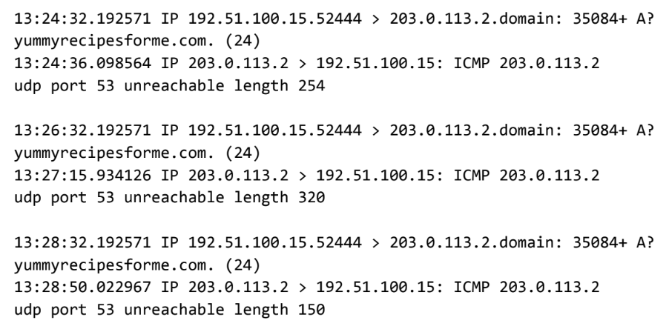

Part 1: Provide a summary of the problem found in the DNS and ICMP
traffic log.

The UDP protocol reveals that: it is a DNS port, it uses to translate domain name into IP address, but the server is unreachable

This is based on the results of the network analysis, which show that the ICMP echo reply returned the error message: the udp port 53 is unreachable

The port noted in the error message is used to: indicates the port that can’t reached or access

The most likely issue is: there is no service was listening on the receiving DNS port so there could be a malicious attack on the DNS server

Part 2: Explain your analysis of the data and provide at least one cause of the incident.
Time incident occurred: 1:24 p.m., 32.192571 seconds. (the first timestamp)

Explain how the IT team became aware of the incident: because several customers of clients reported that they were not able to access the client company website www.yummyrecipesforme.com, and saw the error “destination port unreachable” after waiting for the page to load.

Explain the actions taken by the IT department to investigate the incident: they can run a test using a network protocol analyzer tool tcpdump/wireshark

Note key findings of the IT department's investigation (i.e., details related to the port affected, DNS server, etc.): the port that is effected is the DNS server

Note a likely cause of the incident: server is down, firewall block the connection, or DoS/DDoS attack

